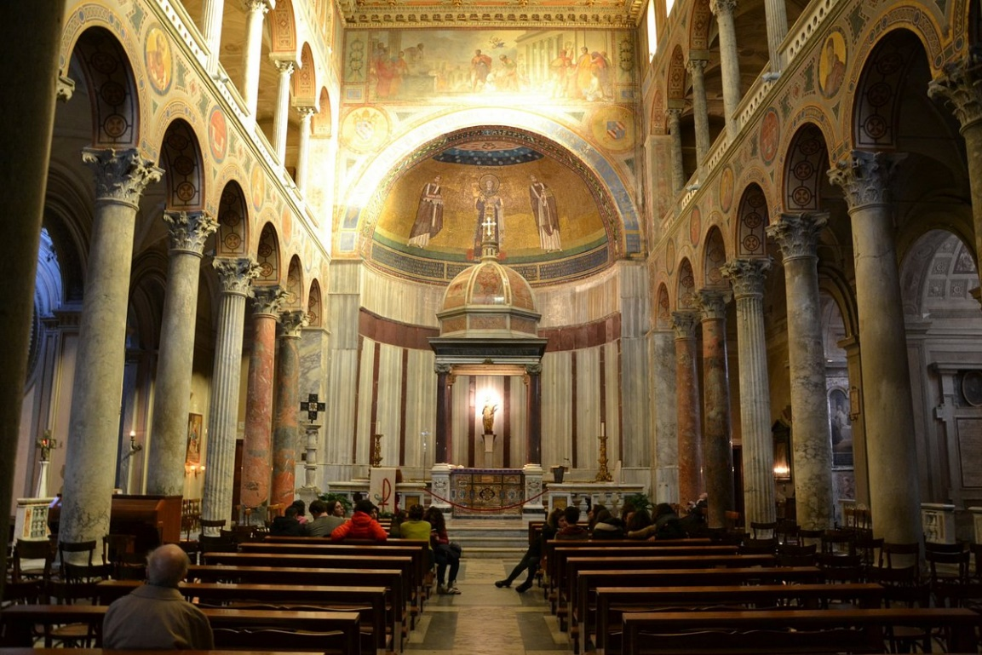
“Communion” from The Geometry of Love by Margaret Visser (HarperCollins: Toronto, 2000) pgs 80-84.

The altar where the Mass is said, together with the bread and wine of the Eucharist itself, combine to express Christ’s death – and his life. It is in order to remember that death the Eucharistic table in a Catholic church is referred to as an altar, and is frequently made in the shape of one. (The Eucharist, in fact, does not require an altar, or even a table-any surface will do.)

The idea of sacrifice – of killing a creature in order to achieve both human togetherness and an encounter with the divine – has been found everywhere on earth; a raised slab on which a sacrifice is performed is known as an altar. Sacrifice may be as old as religion itself, and almost as old as the hunting and killing by human beings of other animals for food. Christianity, however, rejected blood sacrifice; this was in its time one of the most revolutionary aspects of the new religion. According to Christians, mediating sacrificial victims were no longer needed, for in the death of Jesus, God himself had become the victim, once and for all. It was the ultimate epiphany of his love: God had suffered as a victim suffers, and continues this solidarity with all victims. Christ's death at the hands of human beings definitively revealed the horror inherent in violence and made every subsequent act of violence an outrage. Scapegoating and violence continue in the world, but never again can they escape the light that reveals them for what they are.

The altar used as a Eucharistic table in a church is symbolic. It remembers, first of all, the ancient sacrificial altar at the Jewish temple. We saw earlier that the exterior columns of classical Greek and Roman temples became interior columns in a Christian basilical church. The altar, which stood outside both a pagan temple and the Jewish temple, is brought right into the centre of a church like Sant' Agnese's. It becomes the Christian holy of holies, the point of encounter between God and the group of people seeking him, between God and individual human beings. In Sant' Agnese' s the domed ciborium standing on four columns above the altar recalls the DEBIR or inner sanctum of the Jewish temple.
In earlier centuries curtains were hung between columns such as these; they were closed and opened at appropriate times during the Ritual of the Mass. For the climactic moments the curtains were closed, in respect for the mystery. (Today, in Orthodox Christian churches, there is a screen in front of the altar with doors in it that can be opened and closed, for the same reasons.) Curtains made the ciborium even more suggestive of the tent that once enclosed the Ark containing the Covenant. The Ark enclosed the mystery (the word "ark" gives us the adjective "arcane"); only the high priest, once a year, could enter the room where it was housed.

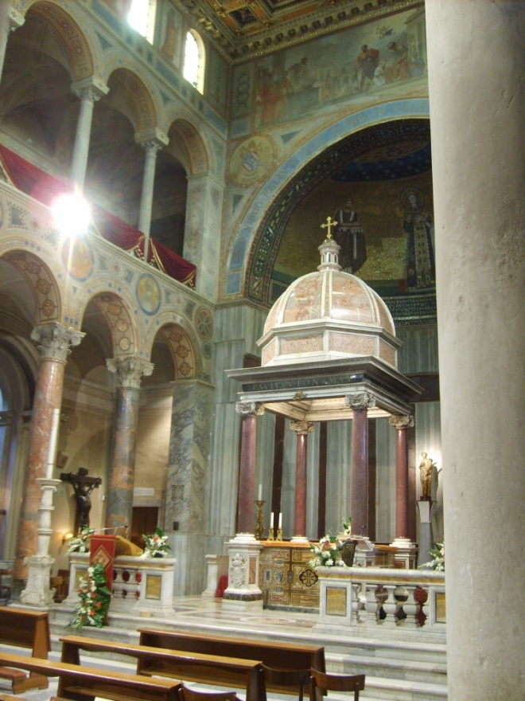
Catholic churches today, without renouncing the idea of mystery, prefer the opposite and equally important symbolism of the availability of God, his desire that human beings should approach him. They therefore prefer the altar, and the ciborium if there is one, to be curtain-free, screen-free, and open. In Sant’ Agnese the space under the dome, like the temple's DEBIR, is in the shape of a perfect cube. Modern churches rarely have a ciborium, but there is usually some attention-drawing device suspended over the altar; this can take the form of a circle, in the same tradition as the halo, the crown, and the dome. The tabernacle or "small tent" in a Catholic church (although not the tabernacle on the altar at Santi Agnese' s) often has little curtains covering the door, or even a veil that covers all of it, to remind Christians of the tent that was the origin of the Jewish temple.

Jesus had been put to death, yet Christians believed that he remained with them in the sharing of the bread and wine, which he said were his body and his blood. The Eucharist-the central rite of Christianity-not only symbolizes but also enacts sharing in love. In this ritual a number of great oppositions are articulated and the barriers dividing them collapsed: God and humankind; the group and the individual; death and life; spirit and body; then and now; here, else- where, and everywhere; eternal and temporal; and even meaning and fact ("This is my body").

The first Christians met in private houses, around ordinary tables in dining rooms, needing only bread and wine for their central epiphanic ritual. The elements of the Eucharist are indeed simple--but the meanings encompassed are vast. The action is intended to express union with God: oneness with what is eternally beyond and greater than human capacity. Eating, even before sex, is biological evolution's first step towards transcendence in the animal species because it initiates physical openness to and need for the Other. For Catholic Christians, the Eucharist is God's gift of himself to humankind; and the ultimate sacra- mental mystery of love again takes the form of eating and drinking.

The altar remembers the central belief of Christianity, that from Christ's cruel death, new hope and the possibility of liberation were born for humanity. It concretely embodies the psalmist's poetic metaphor, which Jesus took to mean himself: "It was the stone rejected by the builders that became the cornerstone," the stone upon which the whole edifice depends. Simon, son of Jonah, himself nicknamed Peter, "the stone," was later to comment on the relationship between the crucifixion of Jesus (his "rejection") and his status now as "the corner-stone" of the new view of the world. People who do not believe that Jesus is the Christ foretold will not think him a "corner- stone" at all, Peter wrote; they will find him a "stumbling-block." The latter expression in Greek is petra skandalou, the origin of the English word "scandal"; it means a stone that people fall over. Every altar in a Catholic church must either be of natural stone, or contain a stone element in the top of it, in order to recall this scandalous claim.

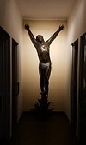
In order to "say" all this, it is essential that nothing be forgotten- neither the pain and the blood, nor the death-even as life and hope are being offered and celebrated. A cross stands on the altar. Nearby, at the end of the left-hand aisle, is a life-sized bronze crucifix, an unusually fine modern work by Uno Gera, who also modelled the Stations of the Cross for Sant' Agnese. It is there to be contemplated by visitors, and it always has offerings of flowers and lights before it. The nailed feet of the dark bronze figure of Christ have been worn golden by the kisses of people doing homage to him.
The Eucharist, also known as Communion, is believed to unite Christ and Christians. Each of the people present at the ceremony eats the consecrated bread, and may also drink the wine: in sharing it, many become one. In order to make this possible, however, the bread must first be broken: the one becomes ~any. This breaking is another version of Christ's death, and also of his continuing life, his Resurrection.

It is the role of Christians, having witnessed the epiphany, to hand on the story, and also to continue it. At the end of the Eucharist the people are sent away, out of the church. The ritual's name is "the Mass," from the Latin Ite, missa est, "Go, you are sent," the words the priest uses when sending the people away. For the ritual now has to be completed in "actual fact," that is in the world outside, where what has been experienced must find its response. After the encounter with God, the other half of the Christian's business remains to be done: the living with other people, and endeavouring to love them. As John's First Epistle bluntly put it, "We are to love, then, because he loved us first. Anyone who says, 'I love God' and hates his brother is a liar, once a man who does not love the brother that he can see cannot love God, whom he has never seen. "

The right Christian response, and the paradoxical way in which true love of God bears fruit, may be illustrated by a story about the fourteenth-century mystic Catherine of Siena. She was once enraptured by a vision of Christ, who at the climax of her ecstasy gave her his own cloak as a precious memorial of what had happened to her. No sooner had Catherine come to her everyday senses than she heard a knock at the door; a beggar stood there, in rags. Immediately, Catherine gave him the cloak.

