Sacramental Preparation
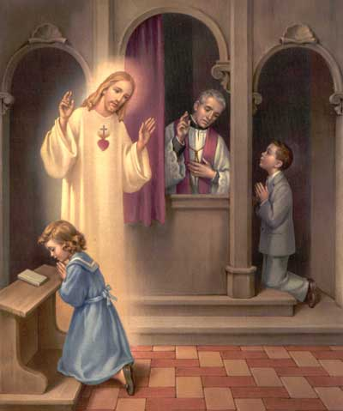
First Reconciliation
For Children grade 2 and older
Prep Course Wednesdays from 6:30 to 7:30 PM
Oct 26, Nov 2, Nov 9,
Nov 16, Nov 23, Nov 30
Sacrament Date Dec 3rd, 2022

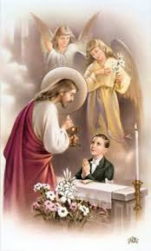
First Communion Preparation
For those who have celebrated First Reconciliation
Prep Course: Wednesdays From 6:30 to 7:30 PM
May 3rd, May 10, May 17, May 24, May 31st, Jun 7
Sacrament Date: The Feast of Corpus Christi
June 11th, 2023
For more info and to register, please contact Shelley at the Parish Office or by e-mail: goodshepherd.catechist@gmail.com
St Paul’s Co-Cathedral Sacramental Preparation
September 2022
Good Day Parents!
We are shortly going to begin preparation classes for your child’s First Reconciliation, followed by First Communion in the spring of 2023. I am pleased to be once again serving St Paul’s Co-Cathedral as the catechist for this journey with your child. The Sacramental Preparation will consist of 12 one-hour classes scheduled on Wednesday evenings. There will be 6 preparation classes in the fall for Reconciliation and 6 Eucharistic Preparation classes in the spring of 2023. To assist in the child’s learning and growth, a parent or guardian is requested to attend the program with your child.
The Sacramental preparation will be held each week in the church hall of St Paul’s Co-Cathedral, starting Wednesday October 26th from 6:30 to 7:30. As of November 2nd, there will be learning stations set up in which the children meditate with their parents with materials provided. The learning stations will be available for children to work from 6:15 to 7:45. We will continue throughout November, leading to the celebration of First Reconciliation on December 3th. First Communion preparation will resume in the Spring, with the sacrament planned to be celebrated June 11th on the Feast of Corpus Christi.
To complete the registration process please return the enclosed registration form to me or to the parish office, with a copy of your child’s baptismal certificate and the attached registration form. The parish requests donations of $25 each for both First Reconciliation and First Communion Preparation in order to cover administrative costs.
If you have any questions or concerns throughout the Sacramental Preparation journey, please contact me. I am looking forward to this journey with your child!

Yours in Christ,
Shelley Timmons
St Paul’s Co-Cathedral Catechist
Parish Office: (306) 652-0033
e-mail: goodshepherd.catechist@gmail.com

