This is my Son, my Chosen; listen to him!
How good it is that you and I here in the church founded upon Peter are able to do what Peter in his wonder and terror on Mount Tabor the mount of the Transfiguration was unable to do… We have built a dwelling for Jesus. Even more wonderful is that Jesus is built a dwelling for himself a tent in the tabernacle in each of us.
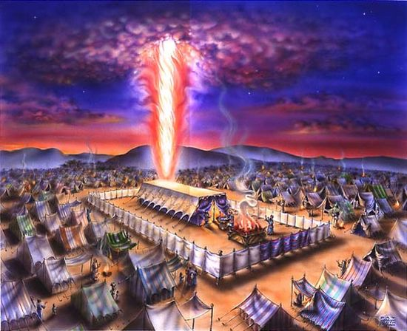
And here in this dwelling that echoes and reveals what each of our hearts has become in the Holy Spirit, you and I are able to hear once again the voice from the cloud saying “this is my Son, my Chosen; listen to him!”
It is an awesome and terrible thing to enter into the cloud which speaks of the presence of the Lord. Israel was led to freedom following a great cloud that shrouded the presence of the Lord. The dwelling place of the tabernacle that contained the Ark of the covenant which they carried with them on their sojourn in the desert was always enshrouded in the SHEKINAH YAHWEH the dwelling of God where God settled to dwell amongst his people.

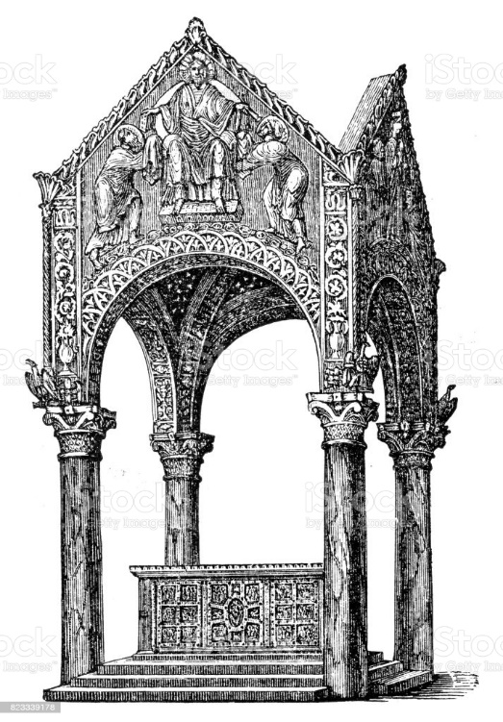
In early dwelling places of God in our church and our early churches the altar was always overshadowed symbolically by cloud… The tabernacle of the four pillars with the canopy shrouding the awesome place from which the voice of God speaks. Soon pray God we too will have such a tabernacle build over our altar were God day in and day out comes to dwell, to transfigure our sight so that we might see him in his glory shining through all of the creation in which he dwells.

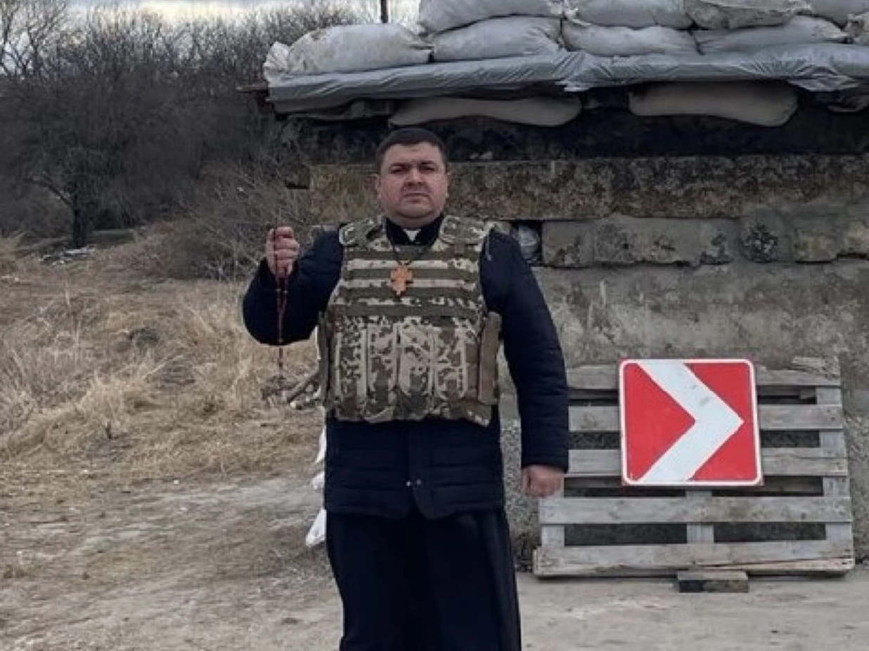
WHERE THERE IS GOD THERE IS VICTORY… So proclaims this article from the National Post and their standing in front of a bunker with a Ukrainian flag stands Father Yuriy. Much of this picture speaks of defeat, because sandbags and a camouflage bulletproof vest tells a story of war and where there is war there is only deprivation and destruction and rapine and murder and all of these are the sickening defeat evil threatens.
Where there is God there is victory… But look closely at this Canadian priest returned to his homeland he has in his hands a weapon of victory: A rosary. Small and insignificant it doesn’t seem humanly to be able to do much against an armored column of tanks. But you know, tanks rust and fall apart, weapons of war are buried deep in the ground just like those who rely on them. But the mystery the glory of Jesus which the prayer of the rosary opens up to be experienced never fades.
This is what happens in the dwelling place the clouded awesome presence of God – his voice rings out amidst the din of bourgeois babbled opinions and the clink of coins of the bankers financing the trade of weapons – “This is my Son, the Chosen; Listen to Him”!
And what do we hear? And what do we see? The Preface I shall soon sing as we enter into the heart of the glory of God tells us “for after you told the disciples of his coming death, on the holy mountain he manifested to them his glory, to show, even by the testimony of the law and the prophets, that the passion leads to the glory of the resurrection.” (Preface for Second Sunday of Lent)

Passion leads to glory.
Passion leads to glory.
How sad when the bored bourgeois heart requires war -induced sensations and feelings to awaken to the presence of God. Every time a rosary is prayed. More wonderfully every time the Eucharist is celebrate the world is shaken up and shaken free light shines in the darkness – the humble glory of God illuminates and transfigures every situation and every place that we are in: every hurt every joy every labour every play just as the sunlight illuminates those pieces of glass to reveal colour unimaginable when they are dark. Just as the Shekinah Yahweh the dwelling place of God shines from this Holy Altar.

God is love and where there is God there is victory.
God is love and where there is God there is victory.

The Lord is my light and my salvation; whom shall I fear?

